Name:  Class: | ____________________________________  ________________ |  | Date:_________
 | Year 11 Foundations Mathematics  Test 4 - 2019  Topic – Subtraction of Whole Number and Money
Total Time: | 35 minutes
Weighting: | 3%
Equipment: | None
$\frac{ }{25}$
SHOW ALL YOUR WORKING OUT!!!!!

Question 1 5 marks
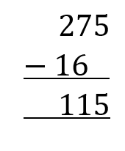
- Show the correct working and give the correct answer.

- Explain how the mistake was made

Question 2 8 marks

Solve the following subtraction problems:

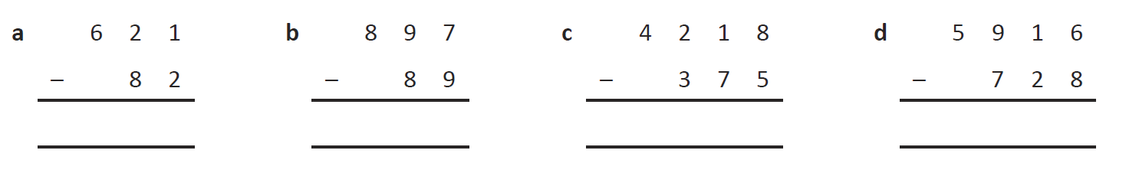

- 5 483 – 27 = | - 3 847 – 1 049 =

Question 3 4 marks

- Ella has $436 saved. She buys a new iPod costing $127. How much money does she have left after the purchase?

- Unfortunately, Ella loses her 4th school jumper for the year. Her mum refuses to pay for another and Ella must cover the cost of $52 herself. How much of her savings does she now have left?

Question 4 8 marks
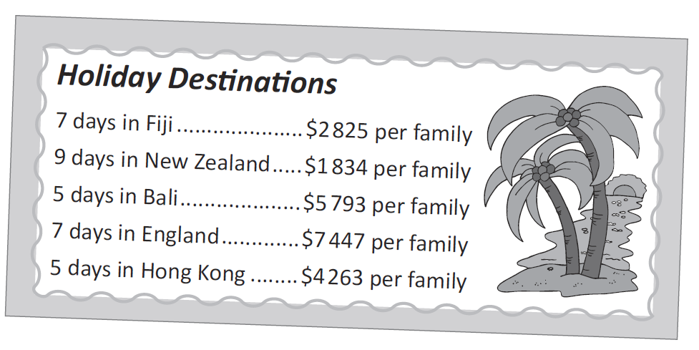
You are working hard to convince your parents that an overseas trip would a far better idea than the usual 2 week camping holidays with Auntie Mable and Uncle Bob. In order to convince them you need to answer the following questions.

- How much cheaper is Fiji than a week in England?

- How much more expensive is 5 days in Bali than 9 days in New Zealand?

- How much would a family save if they decided to go to Hong Kong for 5 days instead of Bali for 5 days?

- How much less would you spend if you went to New Zealand instead of England?

